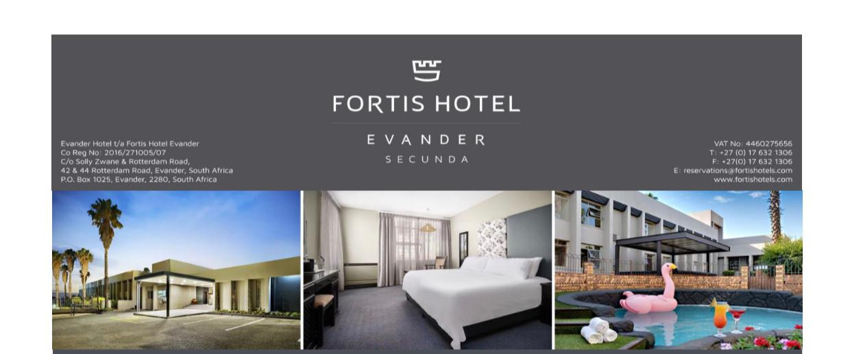

FORTIS HOTEL EVANER

- Rate for the IFSA group: R650 per room. Per person sharing the cost will be R325 per a night.

- Kindly note this rate is excluding breakfast. You need to request breakfast with the hotel if you desire or you could eat a fantastic cheap breakfast at the Spar opposite the conference venue.

TO BOOK:

- Email booking request to Sanelle: gm@fortisevander.com (It’s important to email)
- Make the booking under the group name: IFSA GROUP
- Specify whether you want a room a double bed or two separate beds.
- They require at least a 50% deposit to secure the booking as they cannot hold the 50 rooms they have reserved for us for too long.

The hotel address is 42 & 44 Rotterdam Street, Evander. Its about 15 min drive from the conference venue. https://goo.gl/maps/uetLCM1ovy5LagR66
Tel: 017 632 1306

SHUTTE SERVICE

For those who would like to make use of the Secunda Shuttle Service, here are their contact details: www.secundashuttleservices.co.za or email secundashuttleservies@gmail.com
Tel: 064 908 3740 (They do group bookings and special trips)
