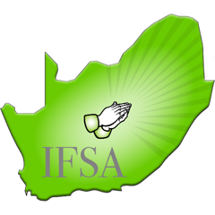
National Office: 292 Msimango Street, Duncan Village. East London 5247
Tel: +2778 097 9752
Email: ifsaprayer@gmail.com

Intercessors for South Africa-National Prayer Conference
6th to 8th September 2018
East London, South Africa

IFSA invites you to our National Prayer Conference on the above dates with the aim of mobilizing intercessors throughout the nation to envision, equip and strengthen them to carry the burden of prayer for the nation. South Africa is holding a general election next year which will be highly contested. We therefore need to ask God for an effective prayer strategy at this critical time in the history of our nation.

Laban Jjumba from Uganda (Africa House of Prayer) will be joining us as our main guest speaker. The urgency of the hour requires us as the Church to respond in prayer and action. We therefore invite you to take part in this national gathering/platform as we co-labour with God in intercession.

To register go to www.ifsaprayer.co.za and click on the Events Section.

The conference begins on Thursday evening 6th September and concludes on Saturday 8th. The registration fee is R200 excluding meals. (Evenings are open to all). We kindly ask that you do an EFT or a bank deposit and then email proof of payment to ifsaprayer@gmail.com. Banking details are below. A program will be sent out at a later date to those who have registered, along with a list of nearby accommodation options and restaurants where you can go for meals. Tea and Coffee will be available. The conference will take place at Downtown Christian Centre (233 Oxford St, Southernwood).

For more information you can contact Donovan Richter our Administrator at ifsaprayer@gmail.com or on 0780979752

Yours sincerely in Christ
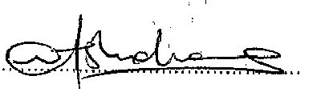
Mangaliso Matshobane
IFSA National Coordinator
+27406350422

Banking Details
FNB – Account Name : SA PRAYER MOVEMENT FOR CHANGE
Account Number : 62 396 583 158
Branch Name : Menlyn Square
Reference : <Your Name and Surname>

